R. Reports Menu: 7. Permit History Report

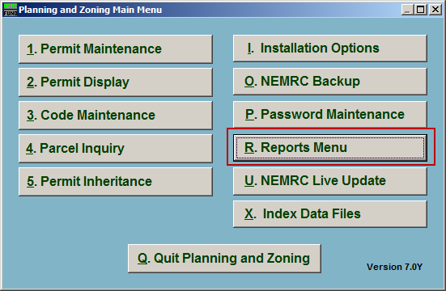
Click on “R. Reports Menu” from the Main Menu and the following window will appear:

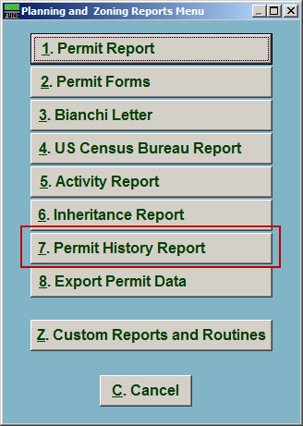
Click on “7. Permit History Report” from the Reports Menu and the following window will appear:

Permit History Report

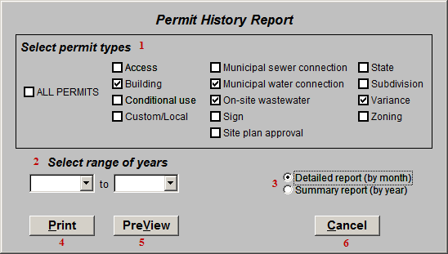
- Select permit types: Click to check the box next to the types of Permits to appear in this report.

- Select range of years: Click the drop down arrows to select the range of years that will be reported on.

- Detailed report OR Summary report: Select whether this report shows the Permit history on a Monthly basis, or on a Yearly basis.

- Print: Click this button to print. Refer to GENERAL PRINTING for more information.

- PreView: Click this button to preview. Refer to GENERAL PREVIEW for more information.

- Cancel: Click “Cancel” to cancel and return to the Reports Menu.

